

WESTERN BALKANS SALW CONTROL ROADMAP
MULTI-PARTNER TRUST FUND

Narrative Progress Report
January – December 2024

Project Title & Project Number |  |  | Country, Locality(ies), Priority Area(s) / Strategic Results
- Project Title: Reduce Risk - Increase Safety III  - Project Number: 01001015  - MPTF Office Project Reference Number: 00140406 |  |  | (if applicable)  Country/Region  Serbia
Priority area/ strategic results
SDG 5, SDG 16
SALW Control Roadmap – Goals 2 and 4
Participating Organization(s) |  |  | Implementing Partners
- Organizations that have received direct funding from the MPTF Office under this project  UNDP Serbia |  |  | - National counterparts (government, private, NGOs & others) and other International Organizations  Ministry of Interior, Institute for Public Health of Serbia “Dr Milan Jovanovic Batut”
Project Cost (US$) |  |  | Project Duration
Total approved budget as per project document:  MPTF /JP Contribution:  - by Agency (if applicable) | $776,135 |  | Overall Duration | 24 months
Agency Contribution  - by Agency (if applicable) |  |  | Start Date | 31 October 2023
Government Contribution  (if applicable) |  |  | Original End Date | 29 October 2025
Other Contributions (donors)  (if applicable) |  |  | Current End date | 29 October 2025
TOTAL: | $776,135
Project Assessment/Review/Mid-Term Eval. |  |  | Report Submitted By
Assessment/Review - if applicable please attach  Yes No Date: dd.mm.yyyy  Mid-Term Evaluation Report – if applicable please attach  Yes No Date: dd.mm.yyyy |  |  | - Name: Maja Brankovic Djundic  - Title: Gender Equality Portfolio Manager  - Participating Organization (Lead): UNDP Serbia  - Email address: maja.djundic@undp.org

I. Background
Recognizing that firearms misuse is a gender problem which continues to affect the lives of citizens of Serbia, the project contributes to decreasing the risk of firearms misuse that leads to violence and suicides. The project also focuses on strengthening the role of women as active participants in SALW control and the implementation of the Roadmap for a Sustainable Solution to the Illegal Possession, Misuse and Trafficking of Small Arms and Light Weapons (SALW) and their Ammunition in the Western Balkans (the Roadmap). The project aims to foster collaboration and knowledge exchange of relevant stakeholders and enhance community response to firearms-related crises and trauma, with a view of restoring the feeling of safety in the wider community.

The project intends to build upon and consolidate the achieved implementation of the SALW Control Roadmap, by focusing on gaps and challenges identified under Goal 2: By 2024, ensure that arms control policies and practices in the Western Balkans are evidence based and intelligence led, and Goal 4: By 2024, significantly reduce the supply, demand and misuse of firearms through increased awareness, education, outreach and advocacy.

The project is based on the following relevant evidence which indicates the impact of SALW misuse:
- 77% of all women killed with firearms in Southeast Europe (SEE) in the period 2019-2021, were killed in the context of domestic violence, while the same holds true for 10% of men killed with firearms. The use of firearms in domestic settings resulted in the highest number of deaths in 2022, exceeding the fatalities in any other context. Consequently, 18 women and 10 men were killed in these incidents. Serbia reported most of these fatalities, with 12 reported victims,
- Data on firearm incidents in the context of domestic violence in SEE for 2023, reveals a trend of overall increase in firearm incidents in the context of domestic violence, with women representing 56% of all victims. The data sheds light on a concerning and reoccurring trend: while domestic violence incidents involving firearms are reported in the lowest numbers compared to other contexts (criminal context, public disputes, undetermined shootings) they consistently account for the highest number of victims with fatal outcomes. This disparity underscores the heightened lethality of firearms in domestic settings, where incidents often result in severe outcomes.
- 17 women were killed in a domestic-partner relationship context in Serbia in 2024, of which 5 were killed with a firearm. In 2023, 28 femicides occurred in Serbia. A total of 20 cases (70%) occurred in the context of domestic/intimate – partner violence and 11 (39%) femicides were committed with firearms (based on media reports). 25 femicides were committed in 2022, with 32% of them committed with firearms.
- The total number of intimate-partner femicide-suicide cases committed with a firearm, varies. The share of firearms-enabled femicides followed by suicide of the perpetrator was the highest in 2017 - 57.69%, and the lowest in 2016 - 18.16%.
- The majority of mass shooting that have occurred in Serbia since 2000, were the direct result of domestic violence involving firearms or involved the murder of a family member or former/current partner. In these mass shootings, the perpetrator was male, while women and girls account for the majority of the victims.
- In 2020 and 2021, Serbia was the highest-ranking country in the SEE region with regards to firearm-related suicides, however the number of reported suicides more than halved in 2021 (14 cases), compared to 2020.
- Men committed 95% of all suicides with firearms between 2012 and 2021. This group can be further narrowed down to men over 45 years old, which shows that men in this age group are accountable for 80% of all firearm suicides in the last ten years.

The project aims to encourage changes of harmful social norms and reduce the risk of firearms misuse by persons who have access to firearms as civilians, or based on their occupation or hobby, as well as those who have access to illegal firearms. The overall goal is to contribute to the meaningful integration of a gender perspective into SALW control policies.

UNDP’s efforts play a significant role in complementing and accelerating the impact of measures introduced by the Government of Serbia in response to the May 2023 mass shootings using a comprehensive approach to firearms misuse prevention and building overall safety in the country. The project also contributes to the implementation of the Law on Weapons and Ammunition (LWA), Law on Prevention of Domestic Violence (LPDV), National Strategy for Combating Domestic Violence, as well as National Strategy on SALW Control 2019-2025.

II. List of Acronyms
Batut Institute for Public Health of Serbia “Dr Milan Jovanovic Batut”
BiH Bosnia and Herzegovina
CSO Civil society organizations
DV Domestic violence
EU European Union
GBV Gender - based violence
LWA The Law on Weapons and Ammunition
LPDV The Law on Prevention of Domestic Violence
MD Multidisciplinary team for establishing a Memorial center in remembrance of victims of the mass
murders in the “Vladislav Ribnikar” Elementary School in Belgrade
MOH Ministry of Health
MOI Ministry of Interior
NGO Non-governmental organization
PD Police Department
Roadmap Roadmap for a Sustainable Solution to the Illegal Possession, Misuse and Trafficking of Small
Arms and Light Weapons (SALW) and their Ammunition in the Western Balkans
SALW Small arms and light weapons
SEE Southeast Europe
ToT Training of Trainers
UNDP United Nations Development Programme

III. Executive Summary
The project made significant steps towards strengthening institutional capacities for response to firearms-misuse risks, and fostering women’s active role in driving policies to combat domestic and firearm-enabled violence in Serbia. To enhance administrative data collection for evidence-based policy making, the project developed a comprehensive framework to improve the Ministry of Interior’s (MoI) collection and analysis of firearm misuse data in domestic violence cases, ensuring the inclusion of sex- and age-disaggregated data. A comparative analysis of legal and institutional solutions in countries with similar social contexts was conducted, identifying best practices for reducing firearm-related femicides. To strengthen women’s role in SALW control policies, the project supported the 3rd Annual Conference of the Network of Women in the Police of Serbia gathering 132 professionals, including high-level state officials, to discuss best practices for preventing violence against women and firearm misuse. Further, the project enabled bilateral networking between 44 women police officers in Serbia and Bosnia and Herzegovina, fostering collaboration on SALW control policies. With a view of improving detection and prevention of firearm-enabled domestic violence and suicides, the project trained 215 healthcare and legal professionals across 67 municipalities on multi-sectoral gender-based violence (GBV) prevention and firearm misuse risk assessment. It has commenced the development of a training of trainers (ToT) program in partnership with the Institute for Public Health, ensuring sustainable capacity-building in healthcare institutions on managing firearms misuse risks. It further supported four CSOs in implementing activities to enhance protection of women from firearm-misuse in local communities, including helpline services, community awareness initiatives and better cooperation with institutions. To increase public awareness and provide support to mechanisms for addressing firearms-related mental health risks, the project delivered specialized training to 31 MoI psychologists and police officers on managing professional trauma related to firearm-related violent incidents. It supported the MoI to launch a nationwide awareness and advocacy campaign on bystander intervention and domestic violence reporting, reaching over 670,000 viewers via national television and 400,000 views on social media. Furthermore, the project initiated the planning of targeted awareness-raising activities addressing firearm-related suicides among men over 45, with expert-led educational efforts. The project also focused on strengthening post-tragedy trauma support and ethical media reporting on firearms-related incidents. With regards to this, the project contributed to identification of international best practices in post-tragedy trauma recovery following the May 2023 mass shootings and their integration into the Government’s efforts to commemorate the tragic events and ensure community reconciliation. The project also trained 31 mental health professionals in Trauma-Focused Cognitive Behavioral Therapy (TF-CBT) to support children, adolescents, and families affected by firearms-misuse risks and incidents, including mass shootings. It further enabled 15 photographers to learn about the ethical depiction of firearm-related violence, ensuring support to trauma-sensitive journalism. The project facilitated collaboration between the multidisciplinary team for establishing a Memorial Center in memory of the victims of the mass shooting at the "Vladislav Ribnikar" elementary school and journalists committed to violence prevention, resulting in the development of a trauma-informed media reporting analysis methodology, to contribute to future learning about the impact and role of media in reporting on mass shootings, particularly with regard to trauma-informed and preventive communication.

The following represents an overview of activities under the “Reduce Risk – Increase Safety III” project, implemented in the period from January to end of December 2024:

Output 1.1 Gender and age data collection practices reviewed, and lessons learned used to facilitate evidence-based policy making and mainstream firearms risks into domestic violence regulations, aims to support the MoI in enhancing its administrative data collection processes, with a focus on addressing missing data sets and improving data classification related to gender and age.

- Within the reporting period, the project contributed to enhancing MoI administrative data collection processes by designing a comprehensive framework for datasets to be collected and analysed by MoI for the purpose of generating analytical reports on misuse of firearms in the context of domestic violence (including incorporation of missing gender and age disaggregated data).
- Additionally, an analysis of legal and institutional solutions of countries with a similar social context to Serbia was completed, to identify good practices that successfully lead to the reduction of femicides and attempted femicides, including those involving firearms-misuse. Furthermore, the methodology for collection of inputs from professionals on needs and obstacles related to effectiveness of legal solutions was finalized, to be applied in the upcoming implementation period.

Output 1.2 Networking and capacity building of women to actively participate in SALW control policies enabled, aims to support greater integration of the gender perspective into SALW control policies, contributing to the efforts to improve the inclusion of women in SALW control and strengthen further networking of women professionals in security forces.

- Within the reporting period, good practices in prevention of violence against women and firearms-misuse for mass shootings were exchanged and cooperation of women in police was fortified at the 3rd annual conference of the Network of Women in the Police of Serbia, held in Belgrade. Gathering 132 participants (111 women and 21 men) from different jurisdictions of the region and Europe, the event included the participation of high-level state officials and experts and was opened by the Prime Minister of Serbia.
- Furthermore, bilateral networking of women from police in Serbia and BiH was enabled through two meetings of associations of women police officers, gathering 44 association members, discussing entry points for enhancing women’s role in SALW control policies and planning future joint activities.

Output 2.1. Conditions for improved detection of potential firearms misuse for domestic violence and suicides and comprehensive prevention support ensured aims to enhance capacities of institutions within the healthcare system for improved filtration of persons at risks of firearms misuse, as well as healthcare’s collaboration with other institutions, to enhance the management of domestic violence cases, taking into account the victims’ safety.

- Within the reporting period, 215 healthcare and legal professionals (187 women and 28 men) from 67 municipalities gained knowledge on multi-sectoral prevention of GBV and recognizing and responding to risks of firearms misuse.
- The project continued the development of the training of trainers program in collaboration with the national partner, the Institute for Public Health “Dr. Milan Jovanovic Batut” and with expert support of engaged consultants. The ToT aims to ensure a sustainable way of improving capacities of healthcare institutions to prevent domestic violence and suicides, focusing on indicators of domestic violence and suicide, and the proper processing of these cases within the system.
- The project has also contributed to enhancing local community safety by enabling 4 local CSOs (selected based on a published call) to implement activities regarding the protection of women from firearms-enabled violence. With the project’s support they have provided helpline support to women exposed to violence, trained women to better understand the risks of firearms misuse, engaged in awareness raising activities and strengthened cooperation with local institutions.

Output 2.2 Information on the harmful effects of underlying practices and attitudes leading to firearms misuse and supportive mechanisms preventing suicides available aims to change mindsets and debunk prejudices that prevent particularly men from seeking mental health support and to deter the misuse of firearms for violence and suicide.

- In the reporting period, 31 (30 women and 1 man) representatives of the MoI Department of Psychological Activities, local PD psychologists, heads of police stations and officers in charge of recruitment, were trained on reducing negative consequences of professional trauma, including those affecting mental health, experienced by professionals involved in violent events with firearms.
- As part of the support to MoI’s communication activities, an awareness raising and advocacy campaign of the Ministry of Interior was implemented, focusing on bystander intervention in preventing domestic violence and need for (anonymous) reporting of violence to the police. The campaign featured videos, audio clip and visuals broadcasted on television, radio, electronic and social media, receiving significant media attention, and achieving over 400 000 views on social media and over 670 000 viewers on the national public broadcasting service (Radio Television of Serbia).
- Also, within the reporting period, two experts were engaged to support prevention of firearm-related suicides in Serbia through educational and community-based activities. Additionally, planning of awareness-raising activities has started, with a view of targeting men over 45 and providing crisis support information to prevent firearms misuse for suicide.
- Project details and awareness raising activities, as well as good practices regarding public informing on firearms misuse for gender-based violence from previous project phases, were presented at UNDP SEESAC 5th Regional Awareness Raising Task Force Meeting.
Output 2.3 Best practice sharing with professionals, media and academia on effective mechanisms for prevention of future firearms related incidents enabled, aims to allow academics and professionals to learn from the experiences of countries that have gone through similar situations, in terms of emergency support programs and long-term community reintegration, as well as measures that have proven effective in preventing occurrence of similar cases in the future.

- Within the reporting period, the project ensured the identification of key action points for healing and reconciliation within the community following the mass shootings at “Vladislav Ribnikar” Elementary School and villages of Mala Dubona and Orašje. Expert support was secured for the Government’s working group to support the first commemoration of the May 2023 mass shootings, to ensure insights based on international best practices on overcoming post-tragedy/mass shootings trauma and community healing.
- Competencies and capacities of 31 mental health professionals (24 women and 7 men) were strengthened to provide Trauma-Focused Cognitive Behavioral Therapy to children, adolescents, and families, direct or indirect victims of mass shootings. The training was delivered by Norwegian experts engaged through the project, to ensure application of international good practices. The training will be followed by a year of support to the trained professionals, ensuring effective and sustained implementation of therapy work addressing psychological needs arising from firearm-related violence and trauma. This is the project’s direct contribution following the Ministry of Education's request for systematic approaches to healing following the May 2023, mass shootings and for providing trauma-focused assistance to those affected, including youth in crisis.
- Regarding the work on enhancing media reporting on domestic and firearms-enabled violence, the project trained 15 photographers and photo-reporters (all women) to better understand the principles of ethical depiction of violence against women and violence committed with firearms in the media.
- The project facilitated the cooperation between the Multidisciplinary (MD) team for establishing a Memorial center in remembrance of victims of the mass murders in the “Vladislav Ribnikar” Elementary School in Belgrade and the group “Journalists against Violence”. Their discussion regarding the impact and consequences of media reporting on the May 2023 mass shootings yielded a media reporting analysis methodology based on principles of trauma-informed journalism and taking into consideration perspectives of victims’ families.

Brief contextual analysis
During 2024, the project implementation has progressed without major hindrances, as has been reported in the submitted quarterly progress reports. The project ensured synergetic action and support for trauma recovery and prevention of mass shootings by engaging with the Ministry for Public Investment (tasked by the Government of Serbia to coordinate the post - May 2023 events healing and reconciliation process and the creation of a memorial), the Ministry of Education, and the Norwegian Embassy in Belgrade to address the needs of survivors and affected communities following the May 2023 events. However, the socio-political context in the country as of November 2024 has changed and should be taken into consideration, as it may affect the roll out of envisaged project activities in the upcoming period. Following the Novi Sad city railway station canopy collapse on 1 November 2024, leaving 15 people dead and two severely injured, a series of mass protests began in Novi Sad. The protests have, since then, spread to numerous cities and towns throughout Serbia and are ongoing. The protests are being led by university students who demand accountability for the canopy collapse. The situation has resulted in social tensions. This situation has been reflected on the communication with national partners, slowing their responses and focus on the project. In the case of the Prime Minister’s Office , which leads the efforts around health system digitalization, their responsiveness to communication has slowed down and this has required the postponement of planned meetings to be also attended by the “Batut” Public Health Institute. Already initiated activities were implemented in the reporting period without significant challenges, however feedback from the Ministry of Interior revealed that the current situation is indeed affecting their work, since police officers are engaged in securing protests in over 300 communities. This also bears an impact on the dynamics and timeline of planned activities with MoI especially those involving MoI senior officers and uniformed police personnel. The project team is closely monitoring the situation and maintaining communication with national stakeholders to develop a plan and establish a realistic timeline for carrying out activities in 2025.

Budget implementation
The project’s budget has been utilized as planned. The total project’s expenditure by the end of the reporting period is USD 383,971.08. Further details are provided in the relevant sections of the report and the annexed provisional financial report.

IV. Overview of progress towards results (for Annual and Final Reports only)
Project output | Project output indicator | Target | Status of project results  (please select one of the following options: [result] achieved/ partially achieved/ not achieved/ activities not initiated) | Achievements against indicators and targets
Output 1.1: Gender and age data collection practices reviewed, and lessons learned used to facilitate evidence-based policy making and mainstream firearms risks into domestic violence regulations. | - The data collection  practices of the Ministry of Interior (MoI) related to firearms misuse in the context of domestic violence reviewed to incorporate missing sex and age disaggregated data.  1.1.2. Evidence based recommendations to improve the effectiveness of legal solutions for preventing and reducing the firearms risk in gender-based violence developed and endorsed | 1.1.1. YES  Recommendations for improved data collection to include sex and age sensitive data  1.1.2. YES  Evidence based recommendations to improve the effectiveness of legal solutions for preventing and reducing the firearms risk in gender-based violence developed | Partially achieved | 1.1.1.Prepared design of comprehensive framework for datasets to be collected and analysed by MoI to generate analytical reports on misuse of firearms in the context of domestic violence (including incorporation of missing se and age disaggregated data). The framework was presented and discussed with several MoI sectors, including the Sector for analytics, telecommunications and information technology, as well as departments responsible for prevention and combating of domestic violence and for administrative affairs.  1.1.2.Completed analysis of legal and institutional solutions of countries with a similar social context to Serbia, to identify good practices that successfully lead to the reduction of femicides and attempted femicides. Completed case studies to be used in discussions with relevant professionals to evaluate the effectiveness of existing legal measures related to DV and GBV.
Output 1.2:  Networking and capacity building of women to actively participate in SALW control policies enabled | 1.2.1. No of women police officers, including members of the Network of Women in the Police capacitated to mainstream gender into SALW control policies and actively participate in SALW control  1.2.2. Improved regional experience exchange and networking of the women police officials in Serbia and Bosnia and Herzegovina on gender mainstreaming in SALW control policies and SALW control. | 1.2.1. At least 50 women from security sector trained on issues relating to development and implementation of gender sensitive SALW control policies  1.2.2.a Up to 100 participants at the regional experience exchange and networking  meetings  1.2.2.b Up to 21 members of the regional networks are introduced to different international best practices during a study visit to a sister network in an EU country | Partially achieved | 1.2.1. 111 women from security sector, including members of the Network of Women in the Police, networked around the topic of prevention of DV, including that committed through SALW misuse. During the previous year, an additional 31 women from the security sector have been included in the networking.  1.2.2.a 44 women, members of associations of  women in the police from Serbia and BiH networked through two bilateral meetings.  1.2.2.b. Not yet initiated
Output 2.1 Conditions for improved detection of potential firearms misuse for domestic violence and suicides and comprehensive prevention support ensured | 2.1.1. No. of healthcare professionals trained to identify risks and effectively implement procedures for reporting and addressing suspected risk of firearms related domestic violence.  2.1.2. Recommendations on improved connectivity and data sharing between state and private healthcare institutions for the Prime Minister’s working group on eHealth developed and considered by the working group.  2.1.3. Recommendations for the new Rulebook on determining natural persons' ability to hold and carry weapons within healthcare system developed.  2.1.4. Exchange of knowledge, dialogue and learning on the implementation of gender-sensitive security vetting and reporting of firearms license holders to prevent misuse of firearms in domestic violence context facilitated | 2.1.1. At least 180 health care professionals trained to better detect and manage cases of violence in collaboration with the police and prosecutor's office  2.1.2. YES  Recommendations on improved connectivity and data sharing between state and private healthcare institutions for the Prime Minister’s working group on eHealth developed and considered by the working group.  2.1.3. YES  Recommendations for the new Rulebook on determining natural persons' ability to hold and carry weapons within healthcare system developed  2.1.4.a up to 150 professionals take part in the dialogues/ knowledge exchange/ learning sessions  2.1.4.b up to 4 CSOs supported to develop and implement community-based actions targeting women whose family members have access to firearms and collaborate with institutions | Partially achieved | 2.1.1. 215 healthcare and legal professionals (187 women and 28 men) from 67 municipalities received training from the project start, to improve their ability to identify risks of firearms misuse in violence and ensure victim safety.  2.1.2. Not yet initiated  2.1.3. Not yet initiated  2.1.4.a Not yet initiated  2.1.4.b 4 CSOs supported by the project to contribute to increased community safety and protection of women from firearms-enabled violence. The CSOs provide local helpline support to women, trainings, raise community awareness on the dangers of firearms-misuse for violence against women and strengthen cooperation with local institutions.
Output 2.2 Information on the harmful effects of underlying practices and attitudes leading to firearms misuse and supportive mechanisms preventing suicides available | 2.2.1. MoI media communication capacities and campaigns to prevent firearms misuse in the community and domestic violence context in place  2.2.2. Professionals providing psychological support within MoI capacitated and police officers informed on supportive mechanisms to prevent negative consequences of professional trauma.  2.2.3. Development of a training curriculum, as well as the training of trainers, aimed at strengthening healthcare system capacities to identify and support individuals at risk of suicide. | 2.2.1. YES  At least 20 media reports containing information about the consequences of firearms misuse as well as critical reviews of firearms (mis)use for domestic violence and gender-based violence  2.2.2.a  At least 25 professionals from MoI’s Department of Psychological Activities trained  2.2.2.b YES - informative activities conducted by the Department among different police units  2.2.3.a YES ToT curriculum developed on how to recognize and provide further and adequate support to persons at risks of committing suicide  2.2.3. b up to 15 trainers from the healthcare system trained on how to recognize and provide adequate support to persons at risks of committing suicide | Partially achieved | 2.2.1. 34 media reports containing information about consequences of domestic violence (including through firearms misuse) published in traditional and electronic media  2.2.2.a. 31 (30 women and 1 man) representatives of the MoI Department of Psychological Activities, local PD psychologists, heads of police stations and officers in charge of recruitment, were trained on reducing negative consequences of professional trauma, including those affecting mental health, experienced by professionals involved in violent events with firearms  2.2.2.b YES – completed in previous reporting period involving 51 MoI representatives (31 women and 20 men, from 29 local police departments.  2.2.3.a ToT development is in progress  2.2.3. b Not yet initiated
Output 2.3. Best practice sharing with professionals, media and academia on effective mechanisms for prevention of future firearms related incidents enabled | 2.3.1. International best practices on post-tragedy/mass shooting community reintegration mapped and shared with professionals, media and academia  2.3.2. Number of journalists with increased capacities and networking opportunities to engage in preventive and ethical reporting on firearms-enabled gender-based violence, including mass shootings | 2.3.1.a Effective practices that have been implemented internationally, aimed at changing masculine stereotypes that lead to harmful incidents with firearms mapped.  2.3.1.b at least 200 participants participate at the best practices and knowledge sharing conference and are introduced to best practice mechanisms for firearms related incidents  2.3.2.a Analysis of media reporting on firearms-related incidents conducted  2.3.2.b up to 10 journalists participate in a study trip to a European media hub to exchange specialist knowledge on the most challenging of media issues and encourage media networking related to ethical reporting on violence and trauma will be organized  2.3.2.c up to 100 participants/ women journalists from the region participate in events that encourage networking, preventive reporting related to firearms-enabled gender-based violence, including mass shootings | Partially achieved | 2.3.1.a Expert from the Brussels-based organization Victim Support Europe identified key action points for healing and reconciliation within the community following the mass shootings at “Vladislav Ribnikar” Elementary School and villages of Mala Dubona and Orašje. The expert participated in the Government’s working group to support the first commemoration of the May 2023 mass shootings and provided insight and support to the group based on international best practices on overcoming post-tragedy/mass shootings trauma and community healing.  2.3.1.b 31 mental health professionals (24 women and 7 men) have strengthened competencies and capacities in providing Trauma-Focused Cognitive Behavioral Therapy for children, adolescents and families who are direct or indirect victims of mass shootings. This is part of the project’s direct response to enhancing resilience to and overcoming trauma in the aftermath of the May 2023 mass shootings.  2.3.2.a Analysis methodology completed, collection of media reports to be analyzed is in progress. Analysis is being carried out in close collaboration and partnership with Multidisciplinary team for establishing a Memorial center in remembrance of victims of the mass murders in the “Vladislav Ribnikar” Elementary School in Belgrade  2.3.2.b Not yet initiated  2.3.2.c Not yet initiated

IV. Progress review
Output 1.1: | Gender and age data collection practices reviewed, and lessons learned used to facilitate evidence-based policy making and mainstream firearms risks into domestic violence regulations
Total budget: | $ 40,000 | Spent: 5,750 | Balance: $ 34,250

1. Progress towards the output
The project aims to support the MoI in enhancing its administrative data collection processes, with a focus on addressing missing data sets and improving data classification related to gender and age. The aim is to improve data collection to include a gender context, to ensure a more comprehensive and accurate data management system within the MoI. Furthermore, the project will organize a task force of experts working on domestic violence prevention and protection, to evaluate the efficacy of current legal solutions and measures related to domestic violence. Based on prior research and lessons learned regarding the combating of firearms misuse for GBV, the screening will identify missing bylaws and procedures that could facilitate a more effective application of laws in practice, to enhance victim protection.

Within the reporting period, the project contributed to enhancing MoI administrative data collection processes by designing a comprehensive framework for datasets to be collected and analysed by MoI for the purpose of generating analytical reports on misuse of firearms in the context of domestic violence (including incorporation of missing sex and age disaggregated data). Additionally, an analysis of legal and institutional solutions of countries with a similar social context to Serbia was completed, to identify good practices that successfully lead to the reduction of femicides and attempted femicides, including those involving firearms-misuse. Case studies were prepared to be used in the upcoming period in discussions with relevant professionals to evaluate the effectiveness of existing legal measures related to DV and GBV.

2. Description of activities implemented during the reporting period

Activity 1.1.1: Provide technical and consultative assistance in analyzing current data collection methodologies related to gender and age and revision of missing gender and age-related data

- During the reporting period, the project facilitated the design of a comprehensive framework for datasets to be collected and analysed by the MoI to generate analytical reports on the misuse of firearms in the context of domestic violence, with a view to incorporating the missing sex and age disaggregated data. The framework is inclusive of all data that needs to be collected as stipulated by various laws and regulations, such as the Law on Weapons, Law on Prevention of Domestic Violence, Criminal Code, Family Law, Law on Minors, etc. This will enable the monitoring of the effectiveness of legal provisions implemented to prevent the misuse of firearms for domestic violence.
- The framework was presented and discussed with several MoI sectors, including the Sector for analytics, telecommunications and information technology, as well as departments responsible for prevention and combating of domestic violence and for administrative affairs. The MoI is continuing work to further identify missing data sets and assess how these data could be extracted from existing records or incorporated into the data management system to address gaps.

Activity 1.1.2: Development of evidence-based recommendations to improve the effectiveness of legal solutions for preventing and reducing risk of firearms misuse in gender-based violence

- During the reporting period, a 3-member expert task force completed an analysis of legal and institutional solutions of countries with a similar social context to Serbia, identifying good practices (at the level of legislation, institutions and practices), that successfully lead to the reduction of femicides and attempted femicides, including cases involving firearms-misuse. In addition to this, the experts have developed the methodology and accompanying case studies to serve as a basis for focus group discussions with professionals engaged in the field of domestic violence prevention and protection (representatives of police, judiciary and social welfare system), to evaluate the effectiveness of existing legal measures and identify those that need to be improved to ensure better prevention of DV and GBV, including femicides committed with firearms.
- Based on findings and inputs to be gathered in the upcoming period, the experts will identify missing bylaws and procedures that could enhance the practical application of laws and provide recommendations to improve the effectiveness of legal solutions for preventing and reducing risk of firearms misuse in GBV, particularly focusing on multi-agency response to risks of SALW misuse for GBV.

3. Difficulties encountered, and measures taken to overcome the problems
- No difficulties encountered.

4. Changes introduced in implementation
- No difficulties encountered.

5. Achievements
- Developed comprehensive data framework that enables the Ministry of Interior to systematically collect and analyze data on firearm-related incidents in domestic violence cases, leading to evidence-driven analytical reports that enhance policy and enforcement strategies.
- Identified and recommended effective legal and institutional practices from comparable countries that have successfully reduced femicides and attempted femicides, providing a foundation for improved regulatory measures to mitigate firearm-related gender-based violence in Serbia.

6. Work plan for [next Q]
Planned activities | Indicators | Budget (US$)
1.Development of recommendations to improve effective legal solutions for preventing and reducing firearms risk in gender-based violence. | 1.Evidence based recommendations to improve the effectiveness of legal solutions for preventing and reducing the firearms risk in gender-based violence developed and endorsed | $34,250

Output 1.2: | Networking and capacity building of women to actively participate in SALW control policies enabled
Total budget: | $131,500 | Spent: 45,338.33 | Balance: $ 86,161.67

1. Progress towards the output
To support greater integration of the gender perspective into SALW control policies, the project contributes to the efforts to improve the meaningful inclusion of women in SALW control and strengthen further networking of women professionals in security forces. Networking among women in the security sector will promote collaboration, knowledge-sharing and advocacy. It will lead to greater incorporation of gender into security policies. By leveraging their collective expertise and influence, women from the security sector can drive positive change, contribute to more inclusive and effective SALW control frameworks, and actively participate in their implementation. This also involves supporting the networking of women in the security sector, by connecting the Network of Women Police Officers from Serbia with women from other security sectors and from the region and other countries, to facilitate the exchange of their experience, challenges, and best practices.

Within the reporting period, to facilitate the networking of women in the security sector and enhance the visibility of women’s role in SALW control, the project assisted in the organization of the 3rd Conference of the Women in Police Network of the Republic of Serbia, held in Belgrade in November 2024, gathering over 100 participants from 12 jurisdictions. Furthermore, assistance to the bilateral networking of women from police in Serbia and BiH was ensured, by gathering 44 women police officers through two meetings and facilitating discussions on strengthening the position of women in the security sectors and possible joint action regarding prevention of gender-based violence and firearms-misuse.

2. Description of activities implemented during the reporting period

Activity 1.2.1: Enabling networking of women in the security sector, facilitating their participation in the development, policy advocacy and implementation of gender-responsive SALW control policies
  - To enable the networking and strengthen the role of women in the security sector, the project facilitated the 3rd Annual Conference of the Network of Women in the Police of Serbia on November 29, 2024, at the Palace of Serbia. This hybrid event brought together 132 participants (111 women, 21 men) from 12 jurisdictions, including law enforcement officials, policymakers, gender equality experts, and representatives of police associations and civil society organizations. High-level engagement amplified the event’s impact, with opening remarks from the Prime Minister of Serbia and participation from key government officials, including the Minister of Interior, Minister of Education, and Minister without portfolio responsible for gender equality, as well as the Commissioner for the Protection of Equality and experts from the Institute for Mental Health. With a focus on preventing and addressing trauma caused by gender-based violence and firearm-related incidents, the conference mobilized stakeholders to strengthen community resilience. Drawing from the May 2023 mass shootings in Serbia, the event featured insights from Dr. Andrew Tatnell, retired Police Superintendent and Research Fellow, on Scotland’s Dunblane mass shooting response, providing lessons learned for law enforcement and first responders. To promote cross-border collaboration, police representatives from 12 jurisdictions (Serbia, BiH, Montenegro, Slovenia, North Macedonia, Greece, Austria, Spain, Sweden, Albania, Romania, Hungary) shared experiences on successful violence prevention programs. The event also amplified the role of women in the security sector, reinforcing their participation in shaping gender-responsive SALW control policies. The conference’s anti-violence messages gained significant media attention, further driving public awareness on firearm misuse and gender-based violence prevention.

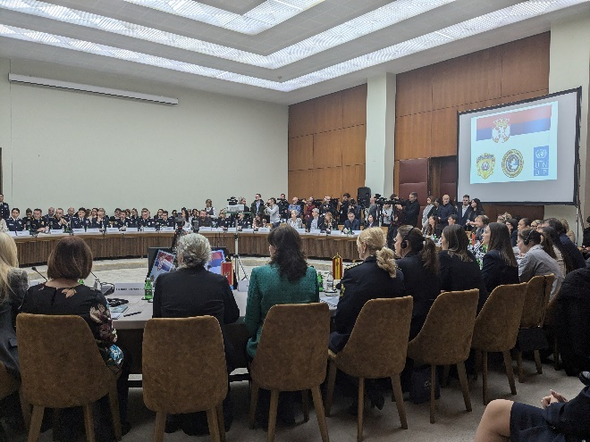
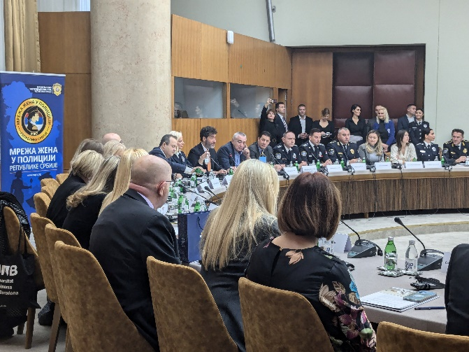
PARTICIPANTS OF THE ANNUAL CONFERENCE
1.2.2: Continued support to associations of women police officials in Bosnia and Herzegovina and Serbia facilitating regional experience exchange and networking around the topic of SALW misuse prevention (joint activity of UNDP CO Serbia and UNDP CO BiH)

- During the reporting period, in cooperation with UNDP BiH, two meetings of the networks of policewomen in Serbia and BiH, were held: in May and in October, 2024. The aim of the first meeting, that took place in Belgrade, was to discuss gender aspects of SALW misuse and identify entry points for greater participation of women in SALW control policies and planning of future steps to this aim. This bilateral networking gathered 20 women from the police, representatives of the "Network of Women in Police of the Republic of Serbia," and two associations operating in Bosnia and Herzegovina - the Association "Network of Women Police Officials" and the "RS Ministry of Interior Women Police Officials Network". In addition to this, the meeting was attended by representatives of UNDP BiH and Serbia and UNDP SEESAC, as well as members of the group “Journalists against Violence”. The meeting provided an overview of SALW Roadmap priorities and developments, as well as a presentation of gender aspects of SALW misuse and relevant legislative framework. Members of the group “Journalists against Violence” presented the benefits of women’s networking and shared trends in media reporting on SALW misuse and domestic violence and role of police in collaboration with media in changing attitudes on SALW misuse for violence against women. After discussing ongoing initiatives on gender and SALW, meeting participants reviewed possible entry points for women’s participation in SALW control and next steps. The second meeting, organized in Sarajevo, gathered 24 members of associations. It included a presentation of the activities of the BiH Ministry of Security’s activities related to the implementation of the Law on Gender Equality. The meeting also included a presentation and discussion related to challenges of women working in the police and overcoming them and examples of activities of associations of women in the police. Furthermore, opportunities for active participation of women in the development of strategic documents related to SALW control in Serbia and BiH were discussed. Joint planning of future activities was also initiated, through exchange of ideas on a joint study visit to an EU-based association of policewomen.
- These activities were implemented in cooperation with UNDP CO BiH (through their project: LEAD – Law Enforcement Agencies’ Development in Small Arms and Light Weapons Control).

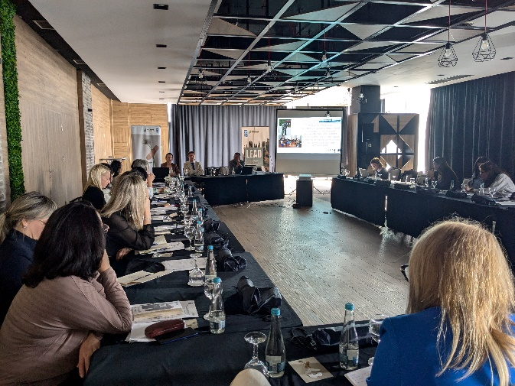
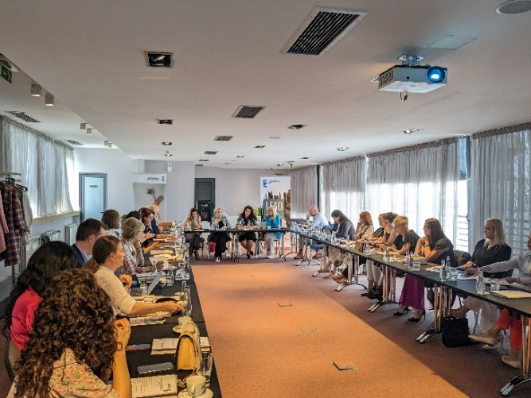
3. Difficulties encountered, and measures taken to overcome the problems
BILATERAL MEETING IN BELGRADE (LEFT) AND IN SARAJEVO (RIGHT)
- No difficulties encountered.

4. Changes introduced in implementation
- No changes introduced.

5. Achievements
- Good practices in prevention of violence against women and firearms-misuse for mass shootings were exchanged and cooperation of women in police was fortified through the annual conference of the Network on Women in the Police of the Republic of Serbia. The event gathered 132 participants from 12 different jurisdictions in the region.
- Gender dimensions of SALW misuse discussed and entry points for enhancing women's roles in SALW control policies identified through bilateral networking of women from police in Serbia and BiH gathering 44 representatives of associations of policewomen.

6. Work plan for Q1 2025

Planned activities | Indicators | Budget (US$)
1.Planning and implementation of capacity building/advocacy activities of the Network of Women in the Police of Serbia.  2. Planning of bilateral meetings of networks of women police officers in Bosnia and Herzegovina and Serbia and EU study visit, facilitating regional experience exchange and networking around the topic of SALW misuse prevention | - No of women police officers, including members of the Network of Women in the Police capacitated to mainstream gender into SALW control policies and actively participate in SALW control  - Improved regional experience exchange and networking of the women police officials in Serbia and Bosnia and Herzegovina on gender mainstreaming in SALW control policies and SALW control. | $86,161.67

Output 2.1: | Conditions for improved detection of potential firearms misuse for domestic violence and suicides and comprehensive prevention support ensured
Total budget: | $210,000 | Spent:$121,544.09 | Balance: $ 88,455.91

1. Progress towards the output
The project works to improve the healthcare system's ability to identify individuals at risk of firearm misuse and to collaborate with other institutions, particularly the police and public prosecutor’s offices, to manage cases of domestic violence reported by the health system while ensuring the safety of the victims. The project keeps track of the current process of healthcare digitalization, which, among other things, envisages the establishment of interconnectivity of databases and data sharing between state and private healthcare institutions, to gain better insight into patients’ health status and firearms possessions, to enable healthcare workers to thoroughly and professionally assess the risk of firearms misuse for violence or suicide. The project works to provide recommendations for the new Rulebook on determining natural persons' ability to hold and carry weapons within the healthcare system, by mapping obstacles and developing recommendations with healthcare workers in a collaborative process, as well as communicating perceived deficiencies and recommendations to relevant ministries. The project also enables learning and exchange of knowledge of professionals working on the cases of domestic violence and those working on security vetting to reduce the risk of firearms misuse among legal firearms owners.

Progress towards the output in this reporting period includes the delivery of trainings to 215 healthcare and legal professionals (187 women and 28 men) from 67 municipalities regarding multi-sectoral prevention of GBV and recognizing and responding to risks of firearms misuse. Furthermore, to enable sustainable knowledge dissemination within the healthcare system, engaged experts continued to work on designing a training of trainers program within health institutions, focusing on prevention of GBV, suicide, suicide-femicide, including that committed with firearms. In addition to this, the project has contributed to enhancing local community safety by enabling 4 local CSOs (selected based on a published call) to implement activities regarding the protection of women from firearms-enabled violence. With the project’s support they have provided helpline support to women exposed to violence, trained women to better understand the risks of firearms misuse, engaged in awareness raising activities and strengthened cooperation with local institutions.

2. Description of activities implemented during the reporting period

Activity 2.1.1: Improving healthcare workers’ capacity to identify risks and effectively implement procedures for reporting and addressing suspected risk of firearms misuse.

- Engagement of experts to develop a training curriculum and supporting materials has been completed and planning of the training of trainers for health professionals is in progress. The training of trainers will provide a sustainable way of improving healthcare worker’s capacities to address risk of firearms misuse for violence and suicide, tailored to the needs and challenges health professionals face in everyday practice. It will also enable knowledge dissemination within institutions and achievement of sustainability of knowledge sharing beyond project implementation.

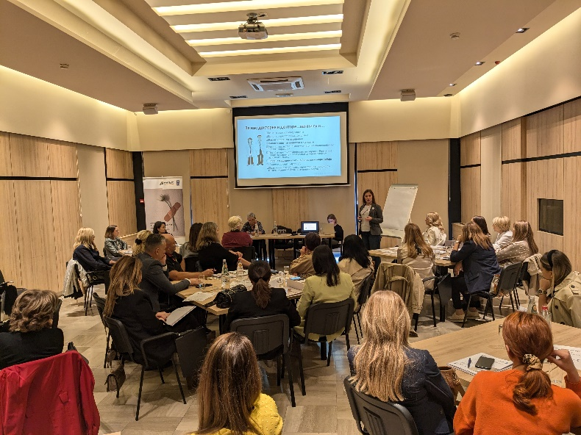
- In the reporting period, one-day trainings were delivered to 215 healthcare and legal professionals (187 women and 28 men) from 67 municipalities (including medical practitioners and specialists from primary, secondary and tertiary healthcare institutions, social workers and lawyers working in health clinics, as well as public prosecutors (from the districts of Zlatibor, Niš, Belgrade, Bačka, Banat and Srem, Pomoravlje, Podunavlje, Šumadija and Braničevo). Based on a needs survey by the “Batut” Institute, this training introduced participants to the phenomenon of domestic violence and recognition of risk factors, the legal obligations of healthcare professionals to participate in preventing violence and violence escalation and ensuring safety from firearms misuse for violence, importance of the work of healthcare teams in violence prevention. Participants also discussed the role of healthcare in determining health conditions for possession of firearms, the importance of monitoring firearms owners’ health and reporting suspected violence (including through firearms misuse). The training provided opportunities for participants to network and better understand the multi-sectoral approach, through group work on case studies based on actual cases involving firearms misuse for violence. The training aimed to increase the ability of medical staff to identify individuals at risk of firearm misuse and to collaborate with other institutions, particularly the police and public prosecutor’s offices, to manage cases of domestic violence reported by the healthcare system while ensuring the safety of the victims. Also, the training focused on improving the participants’ competences to effectively implement procedures for reporting suspected or documented changes in the psychophysical condition of persons who hold a firearms license, and procedures for reporting suspected violence. Participants were provided with guidebooks for healthcare professionals developed as part of the project’s previous phase.
TRAINING FOR HEALTH AND LEGAL PROFESSIONALS IN KRAGUJEVAC

Activity 2.1.4: Organize exchange of knowledge, dialogue and learning on the implementation of gender-responsive security vetting and reporting of firearms license holders to prevent misuse of firearms in domestic violence context
- To strengthen the work of women’s organizations in the community and improve their collaboration with institutions, the project is supporting activities of 4 local women’s organizations aimed at improving the protection of women from violence committed with firearms. The organizations were selected based on the public call for financing projects of civil society organizations, receiving 12 applications in total. The call results were announced on UNDP Serbia’s website, and supported activities will be implemented by 31 July 2025.
- In support of the activity implementation, as well as to raise women’s CSOs capacities to provide support to women in cases of risks from firearms-enabled violence, a meeting was convened in October 2024 providing information on prevention of firearms misuse risks in the context of domestic violence and safety tips for survivors – by the project’s police expert - trainer. Furthermore, grantees were provided with information on administrative and financial aspects of project implementation, reporting and visibility requirements, to ensure smooth implementation of activities and maximization of impact.
- After completing preparatory activities, the organizations’ main activities included:
- Organization name: Women’s Center Uzice
Project title: Let’s Recognize Firearm Misuse Risks on Time
To understand local needs and context related to firearms-misuse prevention, the NGO has mapped available MOI data on the misuse of firearms in the context of violence against women relevant for the Zlatibor District. Cooperation with local police was strengthened through an experience-exchange meeting with the Užice Police Department on the topic on firearms-misuse prevention. Through individual work with female victims of violence, data from 14 women was collected to better understand the impact of firearm possession on reporting and support seeking in situations of violence and plan appropriate response. An awareness raising campaign was organized on social media, amplified by a TV talk show dedicated to violence prevention (including both participation of NGO and local MoI representatives), and street action (where informative fliers were disseminated to 300 citizens), all aimed at raising public awareness about gender-based violence and the risks of firearm misuse.

- Organization name: Human Rights Committee Vranje
Project title: Preventing Firearms Misuse in Domestic and Intimate Partner Violence and Enhancing Safety in the Pcinj District
WORKSHOP IN THE VILLAGE OF VRTOGOS
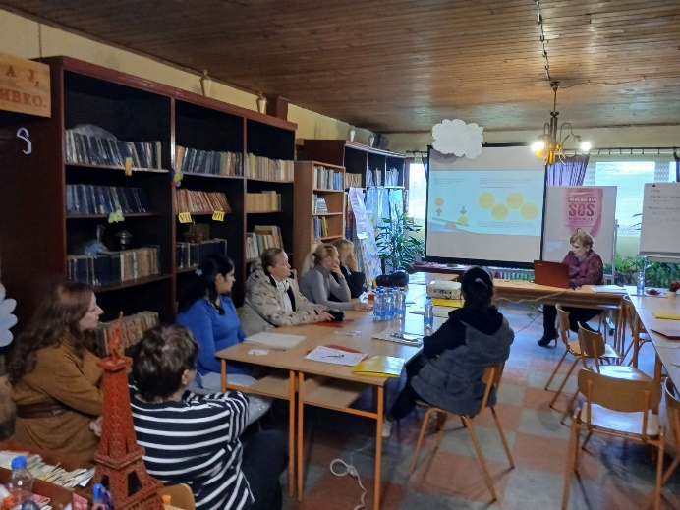
During the reporting period, the project’s support enabled the engagement of 2 helpline support providers to women, potential or current victims of domestic violence. They received a total of 250 calls from 32 women, including 10 new beneficiaries, with two women specifically mentioning the fact that their husbands possess firearms. All other helpline beneficiaries were asked whether a firearm was present in their household and were informed on possible risks in the context of domestic violence. Additionally, two workshops were held in the village of Vrtogoš and the city of Vranje gathering 44 participants (all women). These were organized to inform women on recognition of GBV, potential consequences of firearms misuse in domestic violence and obligations regarding the keeping of firearms in the home, sources of support in cases of violence and reporting violence safely to reduce risks of firearms misuse. Data collection was initiated to map the local context regarding firearms misuse for domestic and partner-relationship violence in Vranje, Bujanovac and Vladičin Han, to inform future training sessions and workshops. Awareness raising efforts of the organization included the positioning of 5 banners on news websites, printing and distribution of 90 posters (placed in public spaces such as city administration premises, police station, etc.) and 210 info - fliers drawing attention to dangers of firearms misuse for domestic violence and safe reporting.

- Organization name: Zrenjanin Educational Center
Project title: Preventing firearms misuse in cases of domestic violence in rural Banat communities
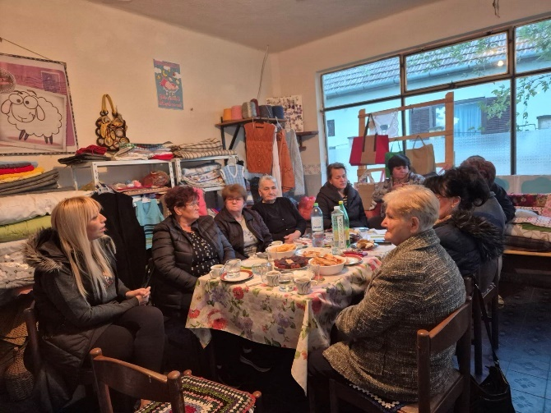
Within the reporting period, two-day workshops were held for representatives of women’s associations from the Banat District rural settlements of Lazarevo, Boka, Iđoš, and Padej, with a total of 51 participants (all women), aimed at enhancing their knowledge on the causes and consequences of gender-based violence and risks of firearms misuse, as well as reporting and legal protection against violence and rules regarding firearms ownership. Furthermore, a two-day seminar was organized for 24 women from Zrenjanin, Sečanj, Kikinda, and Čoka municipalities, which included lectures on the misuse of firearms in cases of domestic violence. The activities not only served to educate women on the topic, but also to enable them to become focal points in their communities for providing valuable information and support to those affected by firearms-enabled violence. All events had a high level of engagement, trust, and positive feedback from participants, who expressed satisfaction with the new knowledge and useful information acquired.
WORKSHOP WITH WOMEN FROM THE VILLAGE OF BOKA

- Organization name: Association of women’s non-governmental organizations “Women against Violence Network”
Project title: A Firearm in the House is Not a Trophy but a Danger
Thanks to the project’s support, the SOS helpline for women experiencing gender-based violence ensured continuous operation and extended its working hours from two to four hours daily (from 12 PM to 4 PM), with representatives of 13 member organizations of the Women against Violence Network on duty according to a prearranged schedule. Within the reporting period, 116 calls were received by the helpline with all callers receiving psychological support, legal information or referrals to institutions to receive further help. One helpline beneficiary reported a firearm threat from her partner, which led to police intervention and the confiscation of the legally owned weapon. Fifteen consultants providing SOS helpline support from organizations within the network completed accredited training for providing social services to victims, while 2/3 of the consultants also participated in trainings on the implementation of Law on Provision of Free Legal Aid and Law on Prevention of Domestic Violence.
3.Difficulties encountered, and measures taken to overcome the problems
- No difficulties encountered.

4. Changes introduced in implementation
- No changes introduced.

5. Achievements
- 215 healthcare and legal professionals (187 women and 28 men) from 67 municipalities received training to improve their ability to identify risks of firearms misuse in violence and ensure victim safety.
- Increased community safety facilitated through support to 4 local CSOs whose activities are aimed at enhancing protection of women from firearms-enabled violence, through provision of helpline support, training of women to better understand the risks of firearms, raising community awareness on the dangers of firearms-misuse for violence against women and strengthening cooperation with local institutions.

6. Work plan for Q4 2024
Planned activities | Indicators | Budget (US$)
1. implementation of trainings for healthcare professionals and Development of training of trainers (ToT) for healthcare workers on response to (firearms-enabled) domestic violence through multi-agency cooperation and provision of support to those in need,  2.Monitoring of activities and provision of support to CSOs that have been selected to receive low value grants. | 1.No. of healthcare professionals trained to identify risks and effectively implement procedures for reporting and addressing suspected risk of firearms related domestic violence.  2.Up to 4 CSOs supported to develop and implement community-based actions targeting women whose family members have access to firearms and collaborate with institutions | $88,455.91

Output 2.2: | Information on the harmful effects of underlying practices and attitudes leading to firearms misuse and supportive mechanisms preventing suicides available
Total budget: | $ 124,000 | Spent: $ 39,158.95 | Balance: $ 84,841.05

1. Progress towards the output
Bearing in mind the social context in which prejudice and stigma prevent people from seeking help in case of mental health problems, which then may lead to firearms misuse, the project supports the MoI’s preventive activities, aligned with the Ministry’s identified needs, and provides support in activities aiming to improve communication with citizens, especially through media and media activities. The project also supports the activities of the MoI Department of Psychological Activities to reduce negative consequences of professional trauma, including those affecting mental health, experienced by professionals involved in violent events with firearms. Additionally, through cooperation with the healthcare and civil sector, the project focuses support to change mindsets and debunk prejudices that prevent men from seeking mental health support, to deter the misuse of firearms for violence and suicide.

In the reporting period, 31 (30 women and 1 man) representatives of the MoI Department of Psychological Activities, local PD psychologists, heads of police stations and officers in charge of recruitment, were trained on reducing negative consequences of professional trauma, including those affecting mental health, experienced by professionals involved in violent events with firearms. In addition to this, the project supported the implementation of the Ministry of Interior’s awareness raising and advocacy campaign, during the 2024 “16 days of Activism against Gender-Based Violence” global campaign, reaching at least 400 000 citizens on social media and over 670 000 citizens through national public television broadcaster (Radio Television of Serbia). The planning of training activities and suicide prevention awareness raising campaign has also commenced. Awareness raising and advocacy activities envisaged within this project, and previous practices in public awareness raising on firearms misuse for gender-based violence applied in previous phases of the project, were presented at UNDP SEESAC 5th Regional Awareness Raising Task Force Meeting.

2. Description of activities implemented during the reporting period

Activity 2.2.1: Support MoI communication activities to prevent firearm misuse in the community and domestic violence context

- During the reporting period, with support of experts engaged through the project to develop communication content, MoI implemented a campaign contributing to awareness raising on (firearms-enabled) domestic violence and reporting violence to the police. MoI’s communication efforts were implemented during the “16 Days of activism against Gender-Based Violence” campaign (25 November – 10 December 2024). Communication activities involved a campaign video and visuals published through both traditional and social media channels. This ensured a wide reach of diverse audiences, including both those directly affected by violence and those who have a prevention role as potential witnesses of violence, with the campaign content reaching 408 905 views on MoI social media only. The communication approach took into consideration the need for greater community engagement and readiness to report violence, bearing in mind that when perpetrators possess or have access to firearms, cases of violence are not reported by victims due to fear of firearms misuse. Bearing in mind citizen’s fear of the perpetrator’s retaliation, the campaign put special attention on anonymous reporting of violence and especially encouraged persons in the community who were bystanders/witnesses to violence to report it. The campaign also raised significant media attention, with many media outlets sharing the campaign video. The campaign was further amplified by media appearances of MoI representatives, alongside UNDP representatives and professionals from other relevant institutions (e.g. judiciary, social protection system), including an appearance on a live national television program on femicide prevention viewed by 671 000 people.

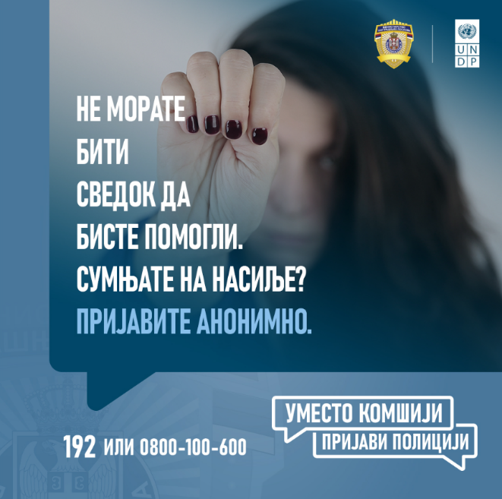
- UNDP Gender Team and Communications Team members were co-trainers at the UNDP SEESAC 5th Regional Awareness Raising Task Force Meeting, taking place in Skopje in April, 2024. the “Reduce Risk – Increase Safety III project was presented among new projects with relevant awareness raising and advocacy activities. Lessons learnt and good practices developed through UNDP Serbia’s work addressing firearms misuse were incorporated into an interactive training on effective awareness raising on gender and firearms misuse held during the meeting.
EXAMPLES OF VISUALS USED IN THE CAMPAIGN

Activity 2.2.2: Support to institutional capacity building and implementation of activities to prevent firearms misuse for domestic violence and suicides among police officers

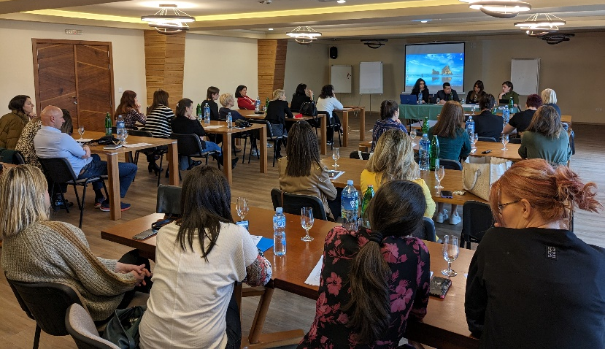
- In February, 2024, a two-day interactive training was organized in Ruma for 31 MoI representatives (30 women and 1 man) addressing suicide of police officers. The event enabled a space for representatives of the MoI Department of Psychological Activities, local PD psychologists, heads of police stations and officers in charge of recruitment, to discuss actual cases, measures taken and systematic solutions for effective suicide prevention. Also, participants focused on the situation and needs of persons of aid in prevention – needs and roles of individuals, persons in management positions within the prevention system. While providing a platform for participants to discuss this sensitive topic, also a safe space was created for participants to exchange positive examples of prevention and discuss opportunities and possible solutions to improve work regarding prevention of firearms misuse for domestic violence and suicides among police officers.
PARTICIPANTS OF THE TRAINING IN RUMA
Activity 2.2.3: Support to learning and community-based activities to prevent firearms misuse for suicide

- Two experts have been engaged to contribute to the reduction of firearm-related suicides in Serbia. One expert is tasked with the development of a curriculum and accompanying learning resources and the delivery of a one-day training to enhance the knowledge and skills of professionals and civilians in recognizing risks associated with access to firearms and in responding to situations involving violent and suicidal behavior. This training will target individuals from the security sector, hunting associations, war veterans, and other groups gathering persons (primarily men) with access to firearms or at risk of firearms misuse. The expert will map and then cooperate with relevant professionals and organizations so that they are able to act as focal points in providing support to individuals from their organization and in the community. The second expert will contribute to enhancing the knowledge, skills, and collaboration of future practitioners in addressing suicide risks, particularly in contexts involving firearms. This expert is tasked with collaborating with relevant tertiary education institutions and developing specialized curricula and accompanying learning materials for future professionals in psychology, social work, medicine, and journalism, focusing on recognizing and responding to risks of suicide and domestic violence, particularly those related to firearms. Furthermore, the expert will conduct training sessions for up to 200 final-year students, enhancing their knowledge and skills in addressing violent and suicidal behavior.
- In cooperation with the SRCE NGO specializing in support to persons at risk of committing suicide, the project began planning of awareness raising activities. The activities will target men over 45 years of age (most at risk of committing suicide in Serbia) through motivating them to seek support in crisis situations and provide information on available immediate support lines. Communication channels and products will be adjusted to main communication habits of the target group, giving priority to more traditional channels and tools (e.g. print rather than social media) and making materials available in neutral environments so as to avoid stigmatization of the target audience (e.g. posters at bus-stops, posters/booklets in medical center waiting rooms, etc.). Furthermore, the activities will improve the availability of relevant prevention materials through the healthcare system, as medical professionals come into contact with a large number of patients, which include those at risk of committing suicide. In the upcoming period, the project will engage communication experts to finalize and develop communication materials.
3.Difficulties encountered, and measures taken to overcome the problems
- No difficulties encountered.
4.Changes introduced in implementation
- No changes introduced.

5. Achievements
- Greater public visibility of the problem of domestic violence and availability of information on reporting violence improved through implemented project-supported awareness raising campaign of the Ministry of Interior aimed at community mobilization against (firearm-enabled) domestic violence, reaching at least 400 000 citizens on social media and over 670 000 citizens through national public television broadcaster (Radio Television of Serbia).
- 31 MoI representatives (30 women and 1 man) networked and capacitated to provide support in preventing firearms misuse for domestic violence and suicides among police officers.
- Awareness raising and advocacy activities envisaged by the project, and good awareness raising practices developed in the previous project phases presented at UNDP SEESAC 5th Regional Awareness Raising Task Force Meeting.

6. Work plan for Q1 2025
Planned activities | Indicators | Budget
1.Support to MoI media and communication activities  2.Finalization and implementation of training and awareness raising activities to prevent firearms misuse for suicide | 1.MoI media communication capacities and campaigns to prevent firearms misuse in the community and domestic violence context in place  2.Development of a training curriculum, as well as the training of trainers, aimed at strengthening healthcare system capacities to identify and support individuals at risk of suicide. | $ 84,841.05

Output 2.3: | Best practice sharing with professionals, media and academia on effective mechanisms for prevention of future firearms related incidents enabled
Total budget: | $ 98,000 | Spent: $ 46,170.12 | Balance: $ 51,829.88

- Progress towards the output
The project works to identify international best practices on post-tragedy/mass shooting community reintegration and improved mass shooting prevention. It furthermore facilitates the mobilization of professionals, media representatives and academia around learning from these incidents to help healing and contribute to more effective prevention of future occurrences. The project also envisages continued support to the group Journalists against Violence (supported by UNDP since 2017) in its efforts to promote learning and partnerships that lead to ethical and preventative media coverage of incidents involving SALW. The project supports the group to analyze media reporting on firearms-related incidents in the context of domestic violence and mass shootings to identify violation of the media code of ethics and propose alternative reporting methods that contribute to prevention. Besides training for selected media and gatherings for journalists, the project will also support exchange of specialist knowledge with a European media hub.

Progress towards this output involved the engagement of an expert from the Brussels-based organization Victim Support Europe who identified key action points for healing and reconciliation within the community following the mass shootings at “Vladislav Ribnikar” Elementary School and villages of Mala Dubona and Orašje. The expert participated in the Government’s working group to support the first commemoration of the May 2023 mass shootings and provided insight and support to the group based on international best practices on overcoming post-tragedy/mass shootings trauma and community healing. Additionally, training for 31 mental health professionals of the Institute of Mental Health and other relevant institutions was implemented, in direct response to the Ministry of Education's request for improving capacities for provision of support (especially to youth) affected by or at risk of crisis situations. The training focused on early detection of youth at risk and managing mental health crises, ensuring that adequate response measures are in place to prevent the possibility of violence incidents, as well as providing Trauma-Focused Cognitive Behavioral Therapy for children, adolescents and families who are direct or indirect victims of mass shootings. The training was implemented by Norwegian experts engaged through the project, who will continue to provide supervisory support to those trained over a period of one year. Also, the group “Journalists against Violence” implemented one workshop for 15 women photographers and photo-reporters, to raise their awareness on the principles of the ethical depiction of violence against women and violence committed with firearms in the media and developed methodology for analyzing media reporting on mass shootings.

2. Description of activities implemented during the reporting period

Activity 2.3.1: Identification of international best practices on post-tragedy/mass shooting community reintegration and improved mass shooting prevention

- An expert from the Brussels-based organization Victim Support Europe was engaged to identify key action points for healing and reconciliation within the community following the mass shootings at “Vladislav Ribnikar” Elementary School and villages of Mala Dubona and Orašje. The expert also participated in the Government’s working group to support the first commemoration of the May 2023 mass shootings and provided insight and support to the group based on international best practices on overcoming post-tragedy/mass shootings trauma and community healing.
- In accordance with the official request of the Ministry of Education, the project implemented a three-day workshop to strengthen the competencies and capacities of 31 professionals (24 women and 7 men) from the Institute for Mental Health, Centre for Youth, and University Clinical Centers in Belgrade, Novi Sad, and Niš in providing Trauma-Focused Cognitive Behavioral Therapy for children, adolescents and families who are direct or indirect victims of mass shootings. The training was delivered on 29-31 October 2024 in Belgrade, by Norwegian experts engaged through the project to enhance the capacities of mental health professionals in Serbia. The experts have extensive experience, as well as long-term practice in TF-CBT. This initiative also includes one year follow-up support to the trained professionals, ensuring the effective and sustained implementation of therapy work addressing psychological needs arising from firearm-related violence and trauma. This is the project’s direct contribution to systematic approaches to healing following the May 2023, mass shootings and for providing trauma-focused assistance to those affected, including youth in crisis.
- The project supported participation of 2 experts of the Victimology Society of Serbia (VSS) at the annual conference of the Victim Support Europe that took place in Zagreb, Croatia, on 22-23 May, 2024. VSS is a member of the Multidisciplinary Team for the establishment of the Memorial Center in memory of the victims of mass the shooting at the “Vladislav Ribnikar” primary school in Belgrade, established by the Government of Serbia. Thus, the project’s support enabled the experts to learn about improving the accessibility of victim support, examples of good practice in providing assistance to victims, about coordination and collaboration of different systems that come into contact with victims, etc. Topics that will particularly inform VSS’s work as part of the multidisciplinary team included discussions on EU’s Role in Establishing a National Framework for Victim Support, as well as examples of good practices regarding comprehensive victim-centered approach in healthcare, and developing inter-sectoral partnerships to benefit victims of mass casualty events. The VSS later dedicated its annual conference to the topic of mass shootings and victim’s needs, attended by members of MoI and the MD team (including parents of victims at the Vladislav Ribnikar school). The conference featured a presentation of the work and findings of the group “Journalists against Women”, aiding further networking and collaboration.
- Continuous information exchange was ensured with stakeholders relevant for response to overcoming trauma and prevention of mass shootings, in the aftermath of the May 2023 events, including with representatives of the Ministry for Public Investment, the Ministry of Education, and the Norwegian Embassy in Belgrade, to ensure synergetic action, as well as response to concrete needs of survivors and communities affected by the mass shootings.

Activity 2.3.2: Continued support to the group Journalists against Violence in its efforts to mobilize national and regional media and promote learning and partnerships that leads to ethical and preventative media coverage of incidents involving SALW

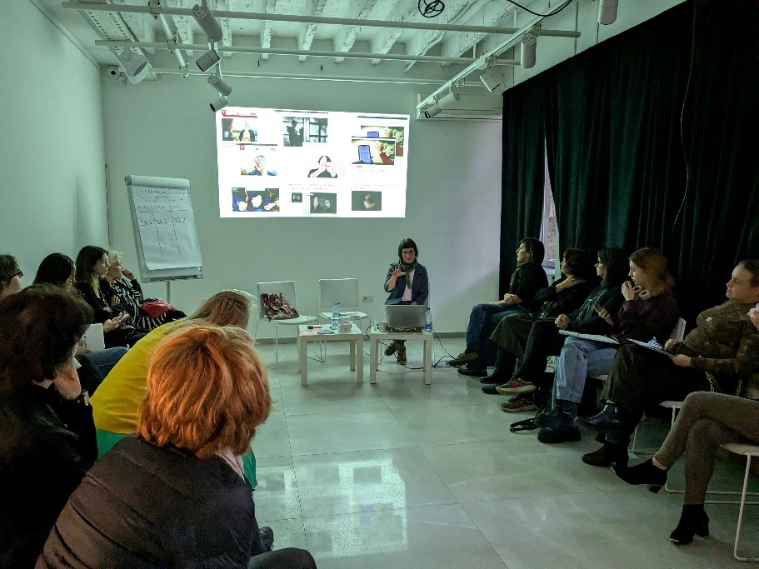
During the reporting period, the project supported the group “Journalists against Violence” to implement a workshop for photographers and photo-reporters on ethical visual representation of (firearms-enabled) gender-based violence, domestic violence and gender equality. The workshop, held in November 2024, gathered 15 women photographers working for specific media houses and freelance photo-reporters, who discussed the phenomenon of violence against women, principles of ethical media reporting on this issue and contribution of visual elements in preventing violence as opposed to sensationalism in media reporting that perpetuates violence and victim blaming. A specific workshop topic was also the current and preferred depiction of firearms and firearms-enabled violence, where participants were provided with recommendations for use of images that serve to raise a critical approach to violence committed with firearms and support responsible media reporting on the topic of violence against women. To familiarize themselves with the joint work of UNDP and the journalist group related to prevention of firearms-enabled violence, the workshop was attended by a member of the MD team for establishing a Memorial center in remembrance of victims of the mass murders in the “Vladislav Ribnikar” Elementary School in Belgrade. The workshop represents a continuation of UNDP’s efforts to network journalists and photographers dedicated to promoting ethical media reporting that leads to the prevention of violence. With a view of enhancing media reporting on firearms-enabled violence including mass shootings, the project enabled cooperation building between the MD team and the group “Journalists against Violence”. Upon discussions regarding the impact and consequences of media reporting on the May 2023 mass shootings and need to provide media professionals with resources and guidelines on ethical media reporting that leads to community recovery and resilience, the group prepared a media reporting analysis methodology based on principles of trauma-informed journalism and relying on perspectives of victims’ families. The methodology suggests analysis of media reports from the mass shooting incidents of May 2023 until court decisions for the perpetrators. The methodology further suggests relying on insights of both the victims’ families as well as those of journalists reporting on both incidents, to ensure that the analysis provides a basis for resources to media in reporting on mass shootings that supports mental health and does not lead to secondary trauma, while contributing to the prevention of such events in the future.
WORKSHOP FOR PHOTOGRAPHERS

3. Difficulties encountered, and measures taken to overcome the problems
- As the scope of activities under 2.3.1. agreed with the national and other stakeholders and counterparts exceeded the initially envisaged and available budget for this activity and given the severity of the trauma caused by the May 2023 mass shootings, and priority of assistance in long-term healing, a request was submitted to the MPTF Secretariat for approval of reallocation of funds between the activities under Output 2.3. This was done to ensure unhindered implementation of agreed support activities. The request was submitted in June 2024 and approved by the MPTF Secretariat. The reallocations between the activity budgets under the Output 2.3. maintain the approved UNDP budget categories of contractual services and travel, with no substantial changes in this respect. This change has no other substantial effects on other planned activities within the project, nor on the overall approved budget.
4. Changes introduced in implementation
- Implementation was in accordance with changes regarding funding of activities under Output 2.3 (as reported in Q2 2024).

5. Achievements
- identified key action points for healing and reconciliation within the community following the May 2023 mass shootings provided support based on international best practices on overcoming post-tragedy/mass shootings trauma and community healing to the Government working group to support the first commemoration of the above-mentioned tragic events.
- Provided direct contribution to resilience to mass shootings through strengthened capacities of 31 professionals (24 women and 7 men) from the Institute for Mental Health, Centre for Youth, and University Clinical Centers in Belgrade, Novi Sad, and Niš in providing Trauma-Focused Cognitive Behavioral Therapy for children, adolescents and families who are direct or indirect victims of mass shootings, through training that involved exchange of expert best practices.
- Expanded the network of stakeholders dedicated to the promotion of ethical media reporting and depiction of (firearms-enabled) violence against women in the media, through workshop including 15 photo-reporters and photographers.

6. Work plan for Q1 2025
Planned activities | Indicators | Budget (US$)
1. Follow-up support provision to trained professionals of the Institute for Mental Health  2. Implementation of analysis of media reporting on mass shootings and SALW misuse, training and networking of journalists and photo-reporters to improve ethical media reporting on violence against women involving firearms misuse | 1.International best practices on post-tragedy/mass shooting community reintegration mapped and shared with professionals, media and academia  2.Number of journalists with increased capacities and networking opportunities to engage in preventive and ethical reporting on firearms-enabled gender - based violence, including mass shootings | $ 51,829.88

V. Monitoring and Evaluation of activities (for Annual and Final Reports only)
During the reporting period, all activities involving work in the field (e.g. trainings, meetings, conferences) were monitored through on-site visits. In addition to this, regular administrative records (participant lists, meeting minutes and reports) and photo documentation was made of all activities involving work with stakeholders. Beneficiaries’ feedback was also collected to gain insight into the effectiveness of activities and further needs. Briefing and de-briefing meetings with project partners were held regularly to facilitate identification of topics of relevance, adjustment of activities to needs of specific target groups and to address future needs – e.g. for meetings of representatives of networks of women in the police.
Trainings with healthcare system representatives were evaluated through questionnaires completed by training participants. These showed that the trainings were highly relevant, as over 90 % of participants gave the highest mark for relevance of topics covered. Furthermore, over 70% stated that the gained knowledge was applicable in practice. Main suggestions of healthcare and legal professionals who participated in training activities were to ensure that such trainings are held more frequently and to continue with practical consideration of the problem through case studies. Furthermore, several participants pointed out the need to have similar training for police and social workers and invite professionals from these systems to the training as well, to contribute to multi-agency cooperation in addressing firearms-enabled violence. As the trainings were planned jointly with representatives of the “Batut” Institute for Public Health, their representatives were also present at trainings, to monitor participant responses, as well as to provide expert insights.
After the completion of activities within this reporting period, the UNDP project team held a briefing to track progress, identify lessons learned and space to improve project delivery and alignment with beneficiaries’ expressed needs. This practice will continue until project closure, with a view of ensuring that a gender sensitive approach is maintained at all stages of the project, and that a gender-responsive approach is applied with regards to identification of opportunities of transformation of institutional practices, development of knowledge materials and awareness raising activities.

VI. Coordination with relevant stakeholders - Partnerships
Continuous communication with project stakeholders and partners was upheld from project initiation. Representatives of the Ministry of Interior were actively involved in the planning and implementation of all related activities carried out in the reporting period, contributing to successful implementation of training activities, networking events, as well as awareness raising efforts. As an example, in an effort to amplify messages regarding greater reporting of domestic violence, UNDP Serbia Gender Equality Portfolio Manager teamed with MoI representatives in several media appearances, where MoI representatives mentioned and praised good cooperation with UNDP. Furthermore, strict coordination was maintained with Members of the Network of Women in the Police of Serbia in the implementation of their 3rd annual conference. They were also actively involved in the implementation of the bilateral meetings of networks of policewomen from BiH and Serbia.

Regular cooperation with the Institute for Public Health of Serbia “Batut” also continued, whose representatives actively collaborated in identifying possible training locations based on surveying of professionals’ needs. Also, the Institute’s representatives take part in the development of, and the Institute’s data is used for planning the training focusing on improving health professionals’ capacities and needs to respond to firearms misuse for violence and prevention of suicides. Further, cooperation was strengthened with the Institute of Mental Health whose professionals received training and follow-up support from the engaged Norwegian experts, based on the request of the Ministry of Education for the project to provide such support.
Cooperation was initiated with the members of the Multidisciplinary (MD) team for establishing a Memorial center in remembrance of victims of the mass murders in the “Vladislav Ribnikar” Elementary School in Belgrade. The cooperation involved the participation of a MD team member in the workshop on ethical media and visual representation of violence against women and violence committed with firearms, implemented within the project. Furthermore, the project facilitated establishment of collaboration between the MD team and Group “Journalists against Violence” around media reporting on the May 2023 mass shootings and discussions on the implementation of a media analysis to be carried out in the upcoming period, to contribute to prevention of mass shootings and post-trauma healing.
A meeting with representatives of the Clinic for Mental Disorders “Dr Laza Lazarevic” in Belgrade was held in December 2024, to explore possible cooperation related to topics addressed by the project, to discuss potential cooperation related to assessment of firearms ownership and misuse risks by clinic patients, as well as the clinic’s contribution to development/advancement of instruments and good practice guidelines to be used in healthcare institutions for evaluation of persons’ fitness for holding firearms.
Cooperation and communication was also ensured with stakeholders relevant for overcoming trauma and preventing mass shootings in the aftermath of the May 2023 events Continued coordination and communication with all relevant project partners and stakeholders was maintained, particularly due to the changes in the socio-political context of project implementation, to mitigate the potential risks to the roll out of project activities in 2025.

VII. Sustainability (for Annual and Final Reports only)
In the reporting period, sustainability was ensured through maintaining and strengthening strategic partnerships with key stakeholders, especially with the Ministry of Interior and the Network of Police Women of the Republic of Serbia, as well as with the “Batut” Institute of Public Health. Representatives of these stakeholders were actively involved in the planning of activities, shaping topics of focus to be addressed through activities, and their representatives were involved in implementation of activities, and in monitoring their smooth implementation. To ensure knowledge gained through the project was applied in practice, training that were implemented during the reporting period (e.g. training for healthcare and legal professionals and capacity building of mental health professionals) focused on the effective implementation of the existing legal framework on prevention of firearms misuse for DV and practices related to overcoming the negative outcomes of trauma caused by violence incidents (including mass shootings). Thus, the project supported stakeholders to fulfil their responsibilities stemming from their mandate and national legal and strategic framework.
Furthermore, the project enabled exchange of good practices and potential transfer of identified successful examples, through facilitating the bilateral networking of representatives of associations of women in the police in Serbia and BiH. Identification of potential entry points for strengthening women’s role in SALW control and improving the status of women in the police force, as well as examples of successful outreach activities for prevention of GBV, can serve as a basis of future work of these associations, either individually or through joint action.
The project also enabled the further broadening of stakeholders mobilized around the prevention of firearm misuse for violence, to ensure an environment where actions against firearms misuse incidents (including mass shootings) are planned through an inclusive approach and are sustained through activities of various stakeholders at different levels. The project initiated cooperation with the members of the Multidisciplinary (MD) team for establishing a Memorial center in remembrance of victims of the mass murders in the “Vladislav Ribnikar” Elementary School in Belgrade (including parents of children lost to the violence incidents of May 2023, their representatives and experts selected by parents) and facilitated collaboration with the group “Journalists against Violence” around the topic of trauma-informed media reporting on mass shootings. This cooperation may serve as a foundation for further collaboration with a view of prevention of mass shootings and post-trauma healing. Furthermore, cooperation with the Clinic for Mental Disorders “Dr Laza Lazarevic” in Belgrade was initiated, to explore possible cooperation related to topics addressed by the project, including assessment of firearms ownership and misuse risks by clinic patients, as well as the clinic’s contribution to development/advancement of instruments and good practice guidelines to be used in healthcare institutions for evaluation of persons’ fitness for holding firearms.

VII. Update on risks and mitigation measures (for Annual and Final Reports only)
The project implementation has progressed with some hindrances related to governmental changes after the 2023 elections. The new prime minister was elected to office only in May 2024, and since the Prime Minister’s Office is leading efforts around e-health, additional time was required to establish cooperation and inform new office members, delaying envisaged project efforts in this field.
The project risk landscape has been strongly affected by the developments in the country that started in November 2024, as they may affect envisaged project activities in the upcoming period. Following the Novi Sad city railway station canopy collapse on 1 November 2024, leaving 15 people dead and two severely injured, a series of mass protests began in Novi Sad. The protests have, since then, spread to numerous cities and towns throughout Serbia and are ongoing. The protests are being led by university students who demand accountability for the canopy collapse. This situation resulted in social tensions, affecting hindered communication with the Prime Minister’s Office which is leading efforts around health system digitalization and required the postponing of planned meetings to be attended by the “Batut” Public Health Institute. While initiated activities were implemented without limitations, feedback from the Ministry of Interior revealed that the current situation is indeed affecting their work, since police officers are engaged in securing protects in over 300 communities. This also bears an impact on the dynamics and timeline of planned activities, especially those involving MoI senior officers and uniformed police personnel. To mitigate the situation, the project team is closely monitoring the situation and maintaining communication with national stakeholders to develop a plan and establish a realistic timeline for carrying out activities in 2025.
An updated risk matrix is annexed to this report.

VIII. Lessons learnt (for Annual and Final Reports only)
The implementation of the project has provided valuable insights into both the successes and challenges of advancing firearm risk reduction, gender-sensitive policies, and trauma-informed approaches in Serbia. Key lessons learned to support ongoing learning, knowledge sharing, and improvements for future programming include:

Key Project Successes and Supporting Factors - Strengthened strategic partnerships and knowledge exchange

Collaboration with key stakeholders—including the Institute for Mental Health and “Batut” Institute of Public Health, Ministry of Interior, Government Working Group and MD Team (composed of parents and experts), and journalists — were instrumental in ensuring evidence-based interventions. By having a deep understanding of needs and challenges of professionals working on violence and firearms-misuse prevention and by incorporating lessons from the aftermath of mass murders, the project successfully aligned activities with real-world needs and was able to contribute directly to building resilience to similar events in the future.

Engagement with policewomen’s networks has revealed key opportunities to improve gender-sensitive approaches to SALW control. The project highlighted entry points for enhancing women's participation in security policy development, reinforcing the need for long-term strategies to address gender disparities in firearm-related violence prevention.

Challenges and Areas for Improvement

Project activities related to improved connectivity and data sharing between state and private healthcare institutions did not commence as intended, since the E-health project, managed by the Prime Minister’s Cabinet, faced delays due to political transitions, including the election of a new government in 2024 and the Prime Minister’s resignation in January 2025.

Furthermore, ongoing protests across 300+ communities since November 2024 requiring the deployment of uniformed police officers, has led to delays in police-related activities planned for 2025, including those related to ensuring conditions for improved detection of potential firearms misuse for violence and comprehensive prevention.

Regarding specific factors that should be taken into consideration in the project’s upcoming implementation, but also future programming is the psychological and emotional impact of crisis events on the community and responding professionals. The May 2023 mass shootings and trials of perpetrators have had a profound emotional toll on victims’ families, first responding professionals, and law enforcement officers. Managing trauma within institutions remains a challenge, particularly in ensuring long-term psychological support and preventing burnout among professionals working on cases of firearm-related violence.

Priority areas for future interventions and recommendations for upcoming implementation and future programming

Incorporate Adaptive Management for Greater Flexibility - Upcoming implementation or future projects should adopt adaptive management approaches to remain flexible in achieving milestones, particularly in the face of political changes, public unrest and/or institutional developments leading to delays. Adjusting work plans and engagement of strategies in response to shifting external dynamics will ensure continued progress.

Increase High-Level Gender Sensitization in MoI Leadership - Given that women remain underrepresented in MoI leadership, targeted gender coaching for high-ranking officials should be prioritized. Developing a structured gender-sensitization program for high-ranking officials would help] ensure a gender-responsive approach to SALW control and security sector policies.

Enhancing Security Checks for Firearm License Holders - Building upon existing collaborations with MoI and the healthcare sector, activities should focus on introducing more robust risk assessment protocols for firearm license applicants and current license holders.

Ensure Sustainable Psychological Support and Trauma-Informed Practices - Sustainable mental health support for survivors, professionals, and communities affected by mass murders must be institutionalized. Trauma-informed approaches should be embedded in both institutional responses and media reporting, preventing re-traumatization of survivors while ensuring responsible public communication. Policy reforms should focus on firearm control, mental health services, and early warning systems to prevent future tragedies in the long run.

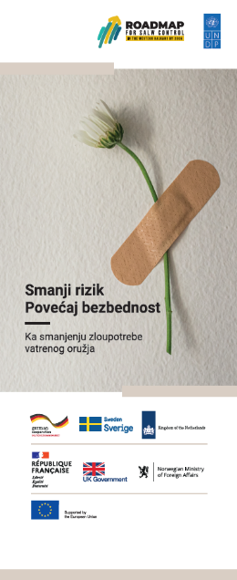
IX. Communication and visibility
Within the reporting period, the project’s visual identity was developed, including a project factsheet and UNDP project sub-page https://www.undp.org/serbia/projects/reduce-risk-increase-safety-3 , as well as a project banner, presentation template, file and notebook design applied on materials used during meetings, trainings and events.

Visibility guidelines were also developed for and distributed to supported CSOs, based on visibility rules of the WB SALW Control Roadmap and UNDP, including proper logo use, acknowledging donors in printed materials and appropriate communication of project support through social media.

Information about the project and donors was disseminated to stakeholders participating in project activities (workshop and meetings organized within the reporting period) through addresses made by the project coordinator and stakeholder representatives. Donor information, including their logos, was included in all agendas, participant lists and presentations.

Project activities have also been used to promote resources developed through previous stages of the project, such as the MoI e-classroom learning modules on DV prevention for police officers, as well as trainings on combating DV through multi-sectoral cooperation on the Judicial Academy’s online learning platform. Previously developed knowledge products were also disseminated to meeting participants (e.g. the Research on characteristics of intimate partner femicide-suicide cases committed with firearms).

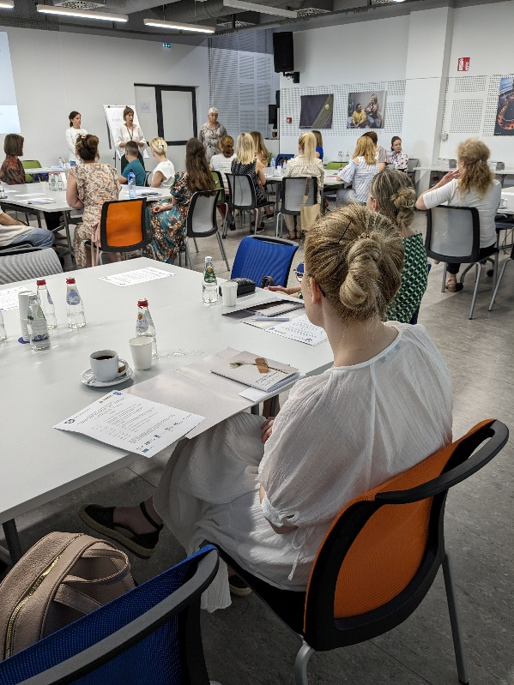
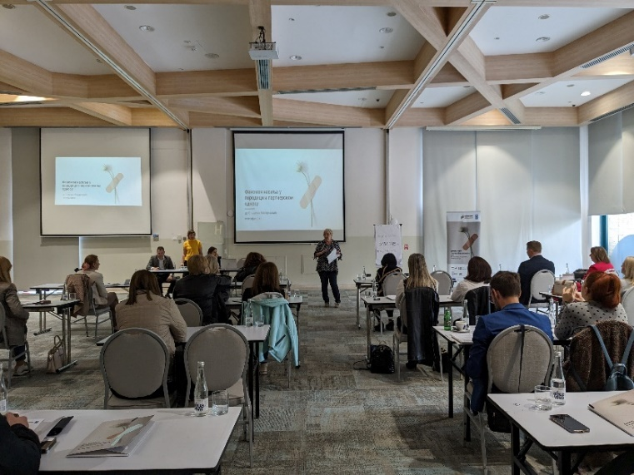
Information about the project donor was included in the public call for support to activities of civil society organizations and associations and accompanying materials and templates:
PROJECT PPT, FOLDER AND BANNER
- https://www.undp.org/serbia/news/deadline-extended-public-call-financing-projects-civil-society-organizations-aimed-improving-protection-women-violence-committed-firearms
- https://www.undp.org/serbia/news/reduce-risk-increase-safety-iii-best-project-proposals-selected

Information on the bilateral meetings of networks of police officers from BiH and Serbia was shared on social media (Facebook and X) of both UNDP and participating networks. Here are some examples:

1)https://www.facebook.com/rswpon/posts/pfbid02nnoRbt7J3fqUnJDnJJfWLQAHmjVwmHUQq78pPFwsvnjCaAx4UVyTCQqsVhMnGyMkl

2)https://www.facebook.com/permalink.php?story_fbid=1007059714470066&id=100054981400623

3)https://x.com/UNDPSerbia/status/1791090981325979875

4)https://x.com/novinarke/status/1791207501980893436

5) https://www.instagram.com/p/DBOD333CkWi/?img_index=1

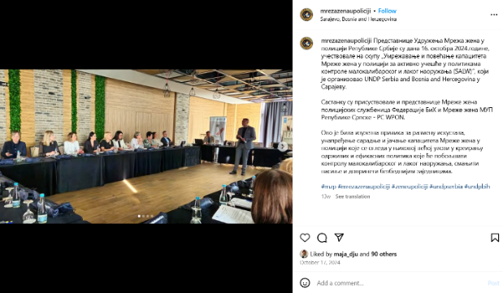
6) https://www.facebook.com/rswpon/posts/849424484011538
SOCIAL MEDIA POSTS OF NETWORKS OF WOMEN IN THE POLICE REGARDING BILATERAL MEETINGS
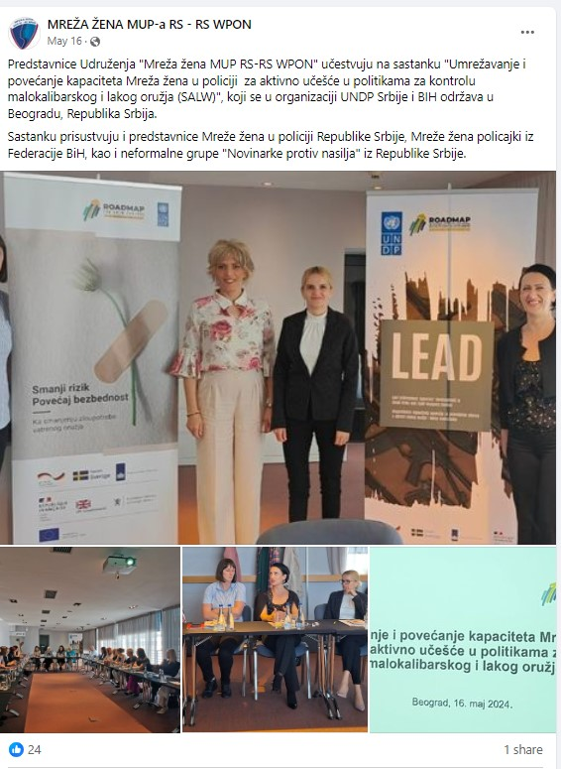

MoI’s awareness raising efforts during the “16 days of activism” global campaign captured public attention, with national to local media joining in the appeals to report domestic violence to the police instead of turning a blind eye. Below are some examples:
Media | Link
Radio television of Serbia | https://www.rts.rs/lat/vesti/drustvo/5598976/nasilje-nad-zenama-policija-prijava-femicid.html#:~:text=U%20okviru%20globalne%20kampanje%20%2216,se%20mo%C5%BEe%20spasiti%20ne%C4%8Diji%20%C5%BEivot.
Euronews Serbia | https://www.euronews.rs/srbija/drustvo/147621/umesto-komsiji-prijavi-policiji-mup-snimkom-na-instagramu-uputio-snazan-apel-gradanima-video/vest
Kurir | https://www.kurir.rs/crna-hronika/9511774/mup-objavio-novi-snimak-sa-snaznom-porukom-o-nasilju
Telegraf | https://www.telegraf.rs/vesti/srbija/4011313-tvoje-cutanje-hrani-nasilje-umesto-komsiji-prijavi-policiji-mup-objavio-novi-snimak-sa-snaznom-porukom
Gradski Online Kikinda (local news portal) | https://gradski.online/umesto-komsiji-prijavi-policiji-kampanja-16-dana-aktivizma/

UNDP Serbia Gender Portfolio Manager also teamed with MoI representatives, as well as judiciary and social welfare professionals within the campaign, in public appearances aiming to raise awareness about the consequences of domestic violence (including through firearms-misuse) and importance of reporting it to responsible institutions:
Media | Link
K1 TV – participation in news programme “News at 7 p.m.” | Play
Radio-television of Serbia, “Thursdays at 9” – weekly TV show | Play
Euronews TV – live appearance during Morning program | Play

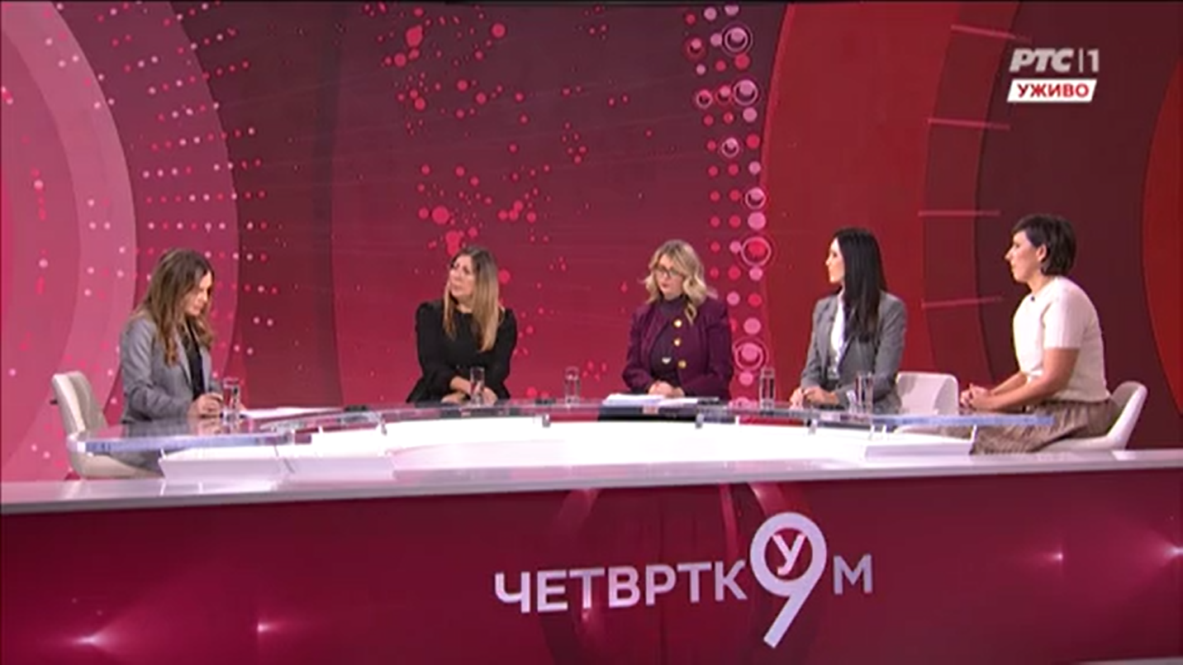
SNAPSHOT FROM LIVE PROGRAM OF RADIO TELEVISION OF SERBIA ON THE PROBLEM OF DOMESTIC VIOLENCE AND FEMICIDES AIRED ON NOVEMBER 28, 2024
To illustrate the received public attention of awareness raising efforts, the weekly TV show, on which UNDP Serbia Gender Portfolio Manager and national partner representatives spoke and raised awareness on domestic violence, aired live on national public broadcasting service (Radio Television of Serbia) rached 671 000 viewers (approximately 10% of Serbia’s population).
Significant media attention to the annual conference of the Network of Women in the Police of Serbia also contributed to ensuring the visibility of women’s role and significance in security forces, with over 30 media reports documenting this event:
No. | Media | Link to news article/video (in Serbian)
1 | kurir.rs | LINK
2 | tanjug.rs | LINK
3 | objektiv.rs | LINK
4 | dnevnik.rs | LINK
5 | telegraf.rs | LINK
6 | tanjug.rs | LINK
7 | studiob.rs | LINK
8 | ktv.rs | LINK
9 | 24sedam.rs | LINK
10 | rtv.rs | LINK
11 | politika.rs | LINK
12 | euronews.rs | LINK
13 | alo.rs | LINK
14 | novosti.rs | LINK
15 | pink.rs | LINK
16 | tanjug.rs | LINK
17 | euronews.rs | LINK
18 | politika.rs | LINK
19 | 24sedam.rs | LINK
20 | n1info.rs | LINK
21 | telegraf.rs | LINK
22 | Beta | LINK
23 | nsuzivo.rs | LINK
24 | RT Vojvodina 1 | Video
25 | K1 | Video
26 | Radio Novi Sad 1 | Video
27 | RTS1 | Video
28 | Radio Beograd 1 | Video
29 | Kanal 9 | Video
30 | Kopernikus | Video
31 | RTS1 | Video

The project’s support was also highlighted through activities of local CSOs, including their social media posts and on printed materials:
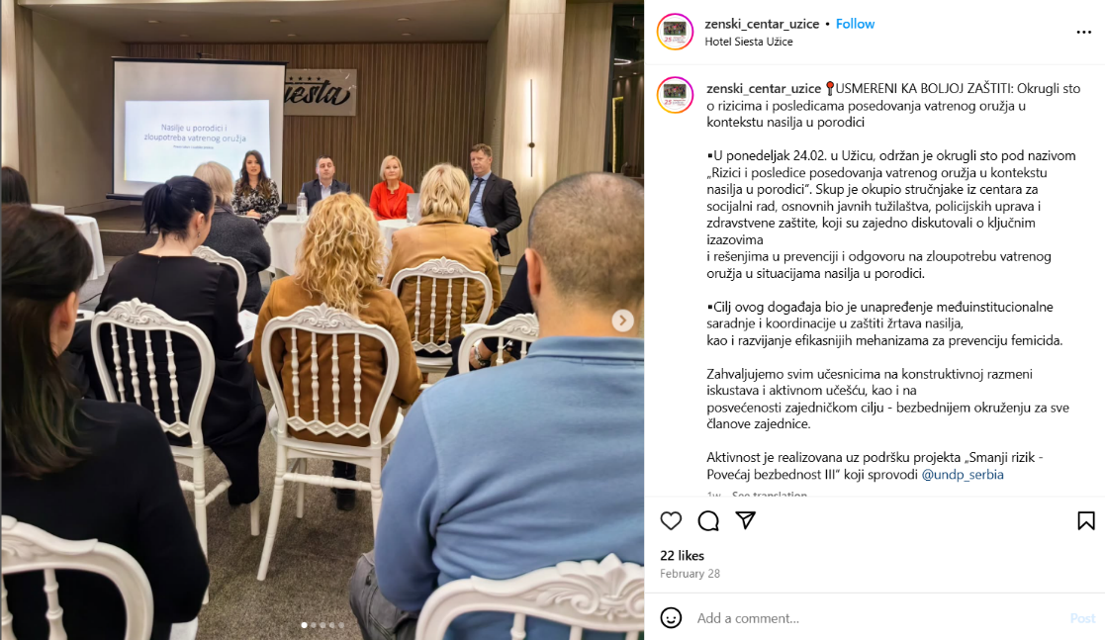
- Women’s Centre Užice Instagram post: https://www.instagram.com/p/DGm6ec1omPy/?img_index=1
- Local media article pointing out UNDP’s support to the work of the Women against Violence Network: https://foruminfo.rs/mreza-zena-protiv-nasilja-raditi-na-jacanju-kapaciteta-i-vidljivosti-sos-telefona/
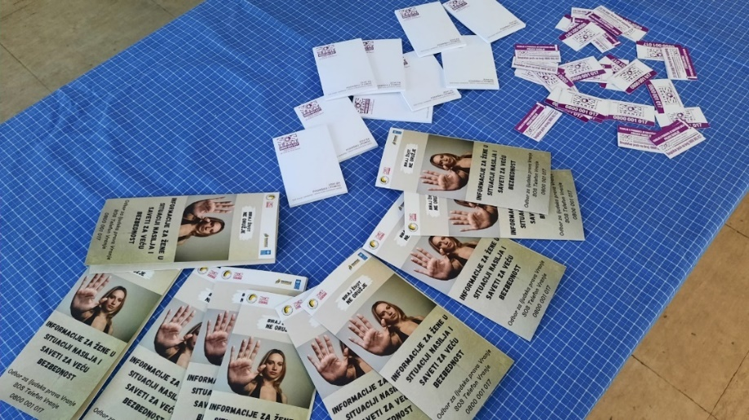
- Booklet on safety of violence survivors printed by the Human Rights Committee Vranje to raise awareness on firearms misuse risks in the context of domestic violence:

Strategic Results, as formulated in the Strategic UN Planning Framework (e.g. UNDAF) or project document;
The MPTF Office Project Reference Number is the same number as the one on the Notification message. It is also referred to as “Project ID” on the project’s factsheet page the MPTF Office GATEWAY
The MPTF or JP Contribution, refers to the amount transferred to the Participating UN Organizations, which is available on the MPTF Office GATEWAY
The start date is the date of the first transfer of the funds from the MPTF Office as Administrative Agent. Transfer date is available on the MPTF Office GATEWAY
As per approval of the original project document by the relevant decision-making body/Steering Committee.
If there has been an extension, then the revised, approved end date should be reflected here. If there has been no extension approved, then the current end date is the same as the original end date. The end date is the same as the operational closure date which is when all activities for which a Participating Organization is responsible under an approved MPTF / JP have been completed. As per the MOU, agencies are to notify the MPTF Office when a programme completes its operational activities.
Firearm Incidents in the Context of Domestic Violence in South East Europe 2019-2021, UNDP SEESAC, available at: https://www.seesac.org/f/docs/Armed-Violence/In-Focus-Armed-Violence-Monitor-on-Firearm-Incidents-in-the-Context-of-Dom.pdf
Victims of firearm incidents in the Western Balkans, UNDP SEESAC, available at: https://www.seesac.org/f/docs/in-focus-armed-violence-monitors_1/In-Focus-Armed-Violence-Monitor-on-Victims-of-Firearm-.pdf
Fiream incidents in the context of domestic violence in South East Europe in 2023, UNDP SEESAC, available at: https://www.seesac.org/f/docs/in-focus-armed-violence-monitors_1/In-Focus-Armed-Violence-Monitor-on-Firearm-Incidents-i_2.pdf
Media report conveying information of the Ministry of Interior of Serbia, Radio-Television of Serbia, December 2024: https://www.rts.rs/lat/vesti/drustvo/5597463/nasilje-zene-prijave-anonimno-femicid-17-ubijenih.html
Report on women’s rights and gender equality in Serbia for 2023, women’s CSO Femplatz, available at: https://femplatz.org/library/reports/2024-03-19_PreneraZena_2023_SR.pdf , as well as monitoring of femicide cases based on media reports by the same CSO, Annual quantitative – narrative report on femicide for 2021, Women against Violence Network, available at: https://www.womenngo.org.rs/images/femicid/FEMICID_Kvantitativno_-_narativni_godisnji_izvestaj_2021_godina.pdf
Characteristics and Prevention of Intimate Partner Femicide – Suicide Cases committed with a Firearm, UNDP Serbia, 2023, available at: https://www.undp.org/serbia/publications/characteristics-and-prevention-intimate-partner-femicide-suicide-cases-committed-firearm
Firearm related suicides in South East Europe in 2021, https://www.seesac.org/f/docs/Armed-Violence/In-Focus-Armed-Violence-Monitor-on-Firearm-related-Suicides-in-SEE-in-2021.pdf
Fire-arm related suicides in South East Europe in 2020, https://www.seesac.org/f/docs/Armed-Violence/In-Focus-Armed-Violence-Monitor-Firearm-related-Suicides-in-SEE-in-2020_1.pdf
Research on relevance of firearms in lives of individuals aged 45+ and self-help strategies in crisis situations, UNDP 2023
The spent amount should cover the period since the beginning of the project until the end of the reporting period.
The spent amount should cover the period since the beginning of the project until the end of the reporting period.
The spent amount should cover the period since the beginning of the project until the end of the reporting period.
The spent amount should cover the period since the beginning of the project until the end of the reporting period.
The spent amount should cover the period since the beginning of the project until the end of the reporting period.
The later if applicable.

